**WEEK – 4**

**MANDATORY HANDS-ON - 1. spring-rest-handson**

1. **Hands-on 1: Create a Spring Web Project using Maven:**

**STEP 1: Go to Spring Initializr**

Open your browser and go to: <https://start.spring.io>

**STEP 2: Fill Project Metadata**

* **Group:** com.cognizant
* **Artifact:** spring-learn

**STEP 3: Add Dependencies**

Click "Add Dependencies" and include:

* Spring Web
* Spring Boot DevTools

**STEP 4: Generate and Extract Project**

* Click **Generate**, it downloads a ZIP file.
* Extract the ZIP to a folder inside your **Eclipse Workspace**.

**STEP 5: Import Project into Eclipse**

* Open Eclipse
* Go to: File → Import → Maven → Existing Maven Projects → Next
* Browse and select the extracted folder → Click **Finish**

**STEP 6: Build the Project via Command Line**

* Open Command Prompt → go to the project folder  
  **Run this command:**

mvn clean package -Dhttp.proxyHost=proxy.cognizant.com -Dhttp.proxyPort=6050 -Dhttps.proxyHost=proxy.cognizant.com -Dhttps.proxyPort=6050 -Dhttp.proxyUser=123456

**STEP 7: Add Logging to Main Class**

Open SpringLearnApplication.java inside:

**src/main/java/com/cognizant/springlearn/**

**Edit it like this:**

package com.cognizant.spring_learn;

import org.slf4j.Logger;

import org.slf4j.LoggerFactory;

import org.springframework.boot.SpringApplication;

import org.springframework.boot.autoconfigure.SpringBootApplication;

*@SpringBootApplication*

public class SpringLearnApplication {

private static final Logger ***LOGGER*** = LoggerFactory.*getLogger*(SpringLearnApplication.class);

public static void main(String[] args) {

***LOGGER***.info("START");

SpringApplication.*run*(SpringLearnApplication.class, args);

***LOGGER***.info("END");

}

}

**STEP 8: Run the Application**

* Right-click on SpringLearnApplication.java  
  → Run As → Java Application

**STEP 9: Verify Console Output**

You should see logs:

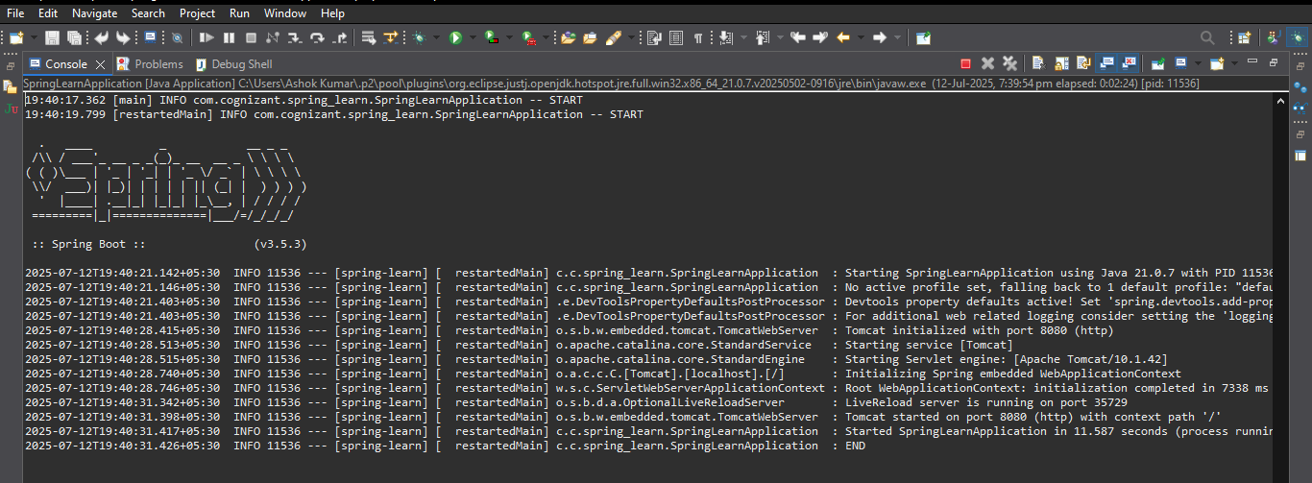

1. **Hands-on 4: Spring Core – Load Country from Spring Configuration XML**

**Steps:**

1. **Create a Project**
2. Go to <https://start.spring.io>
3. Group: com.cognizant
4. Artifact: spring-learn
5. Dependencies: None needed for this task
6. Extract the zip and import it in Eclipse via:
7. File > Import > Existing Maven Projects
8. **Create Country Java Bean**

**📁 Path: src/main/java/com/cognizant/springlearn/Country.java**

package com.cognizant.springlearn;

import org.slf4j.Logger;

import org.slf4j.LoggerFactory;

public class Country {

private String code;

private String name;

private static final Logger ***LOGGER*** = LoggerFactory.*getLogger*(Country.class);

public Country() {

***LOGGER***.debug("Inside Country Constructor.");

}

public String getCode() {

***LOGGER***.debug("Getting code: {}", code);

return code;

}

public void setCode(String code) {

***LOGGER***.debug("Setting code: {}", code);

this.code = code;

}

public String getName() {

***LOGGER***.debug("Getting name: {}", name);

return name;

}

public void setName(String name) {

***LOGGER***.debug("Setting name: {}", name);

this.name = name;

}

*@Override*

public String toString() {

return "Country [code=" + code + ", name=" + name + "]";

}

}

1. **Create country.xml**

**📁 Path: src/main/resources/country.xml**

<?xml version="1.0" encoding="UTF-8"?>

<beans xmlns="http://www.springframework.org/schema/beans"

xmlns:xsi="http://www.w3.org/2001/XMLSchema-instance"

xsi:schemaLocation="http://www.springframework.org/schema/beans

https://www.springframework.org/schema/beans/spring-beans.xsd">

<bean id="country" class="com.cognizant.springlearn.Country">

<property name="code" value="IN"/>

<property name="name" value="India"/>

</bean>

</beans>

1. **Modify SpringLearnApplication.java**

📁 **Path:** **src/main/java/com/cognizant/springlearn/SpringLearnApplication.java**

package com.cognizant.springlearn;

import org.slf4j.Logger;

import org.slf4j.LoggerFactory;

import org.springframework.context.ApplicationContext;

import org.springframework.context.support.ClassPathXmlApplicationContext;

public class SpringLearnApplication {

private static final Logger ***LOGGER*** = LoggerFactory.*getLogger*(SpringLearnApplication.class);

public static void main(String[] args) {

***LOGGER***.info("START");

*displayCountry*();

***LOGGER***.info("END");

}

public static void displayCountry() {

ApplicationContext context = new ClassPathXmlApplicationContext("country.xml");

Country country = context.getBean("country", Country.class);

***LOGGER***.debug("Country : {}", country.toString());

}

}

1. **Run the Application**
2. Right-click SpringLearnApplication.java
3. Select Run As > Java Application

**Console Output:**

